**Assignment - 4** Docker and Kubernetes

|  |  |
| --- | --- |
| Assignment Date | 30 october 2022 |
| Student Name | JEEVANANDH S |
| Student Roll Number | 410119104017 |
| Maximum Marks | 2 Marks |

**Question-1:**

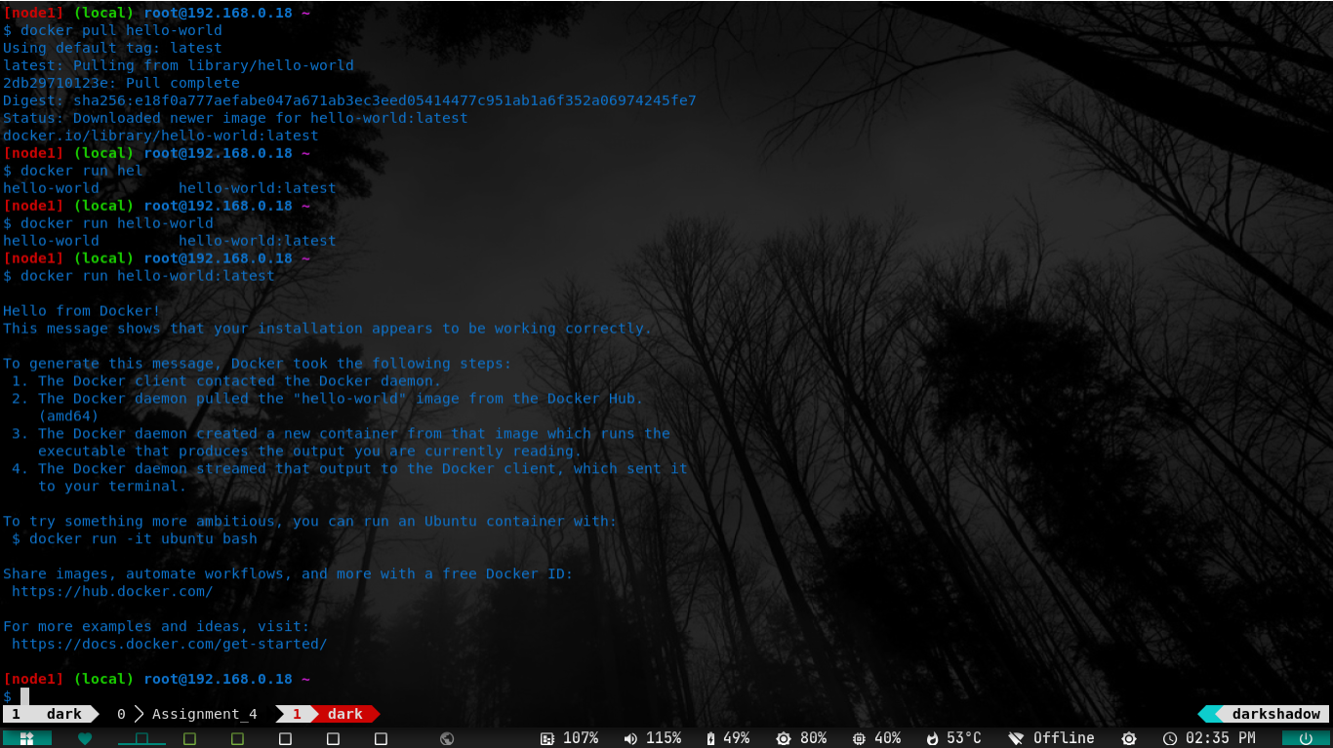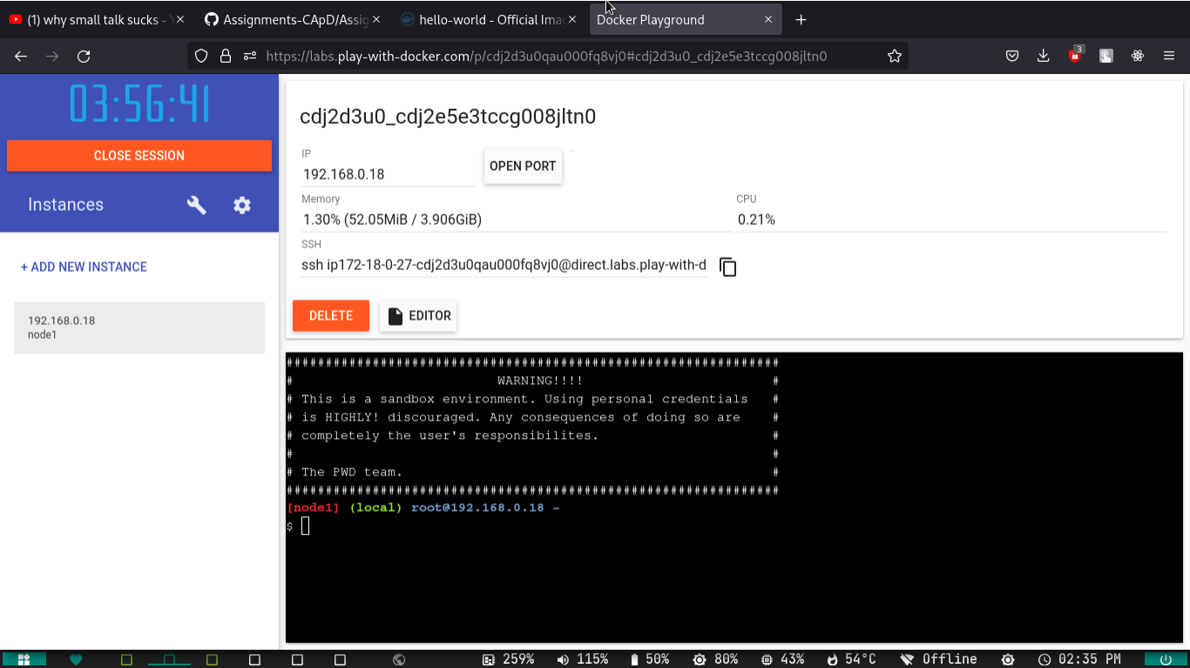1.Pull an Image from docker hub and run it in docker playground.

**Question-2:**

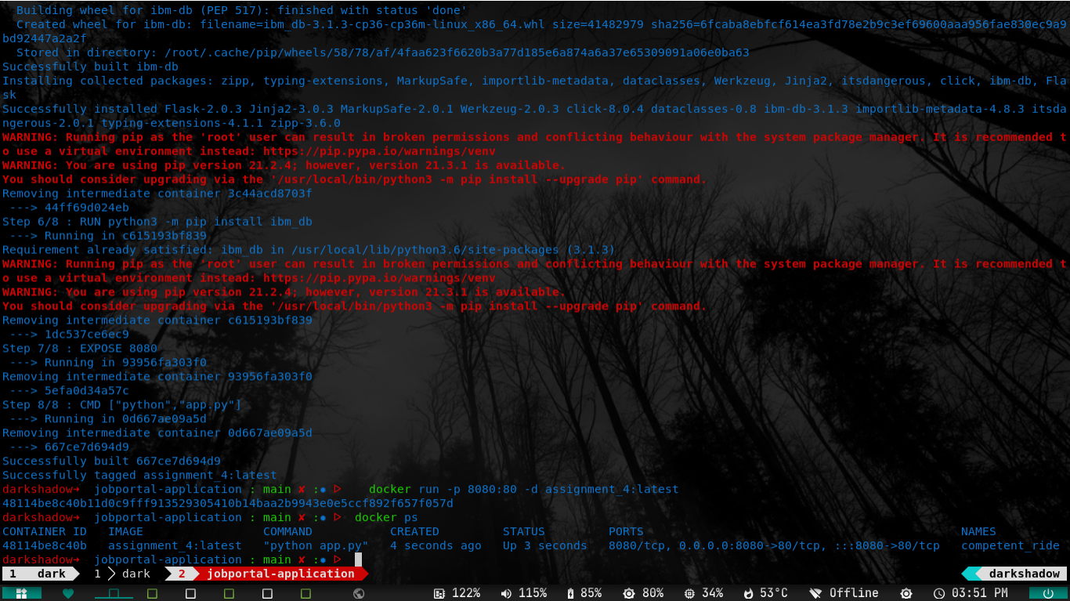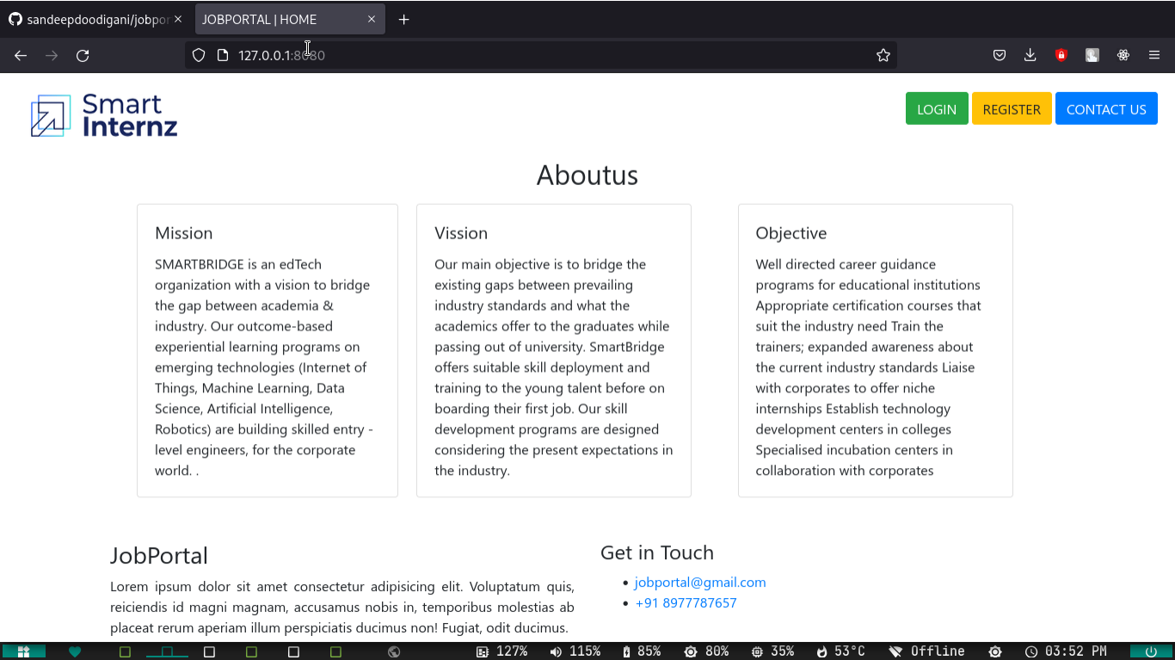2.Create a docker file for the jobportal application and deploy it in Docker desktop application.

Question – 3

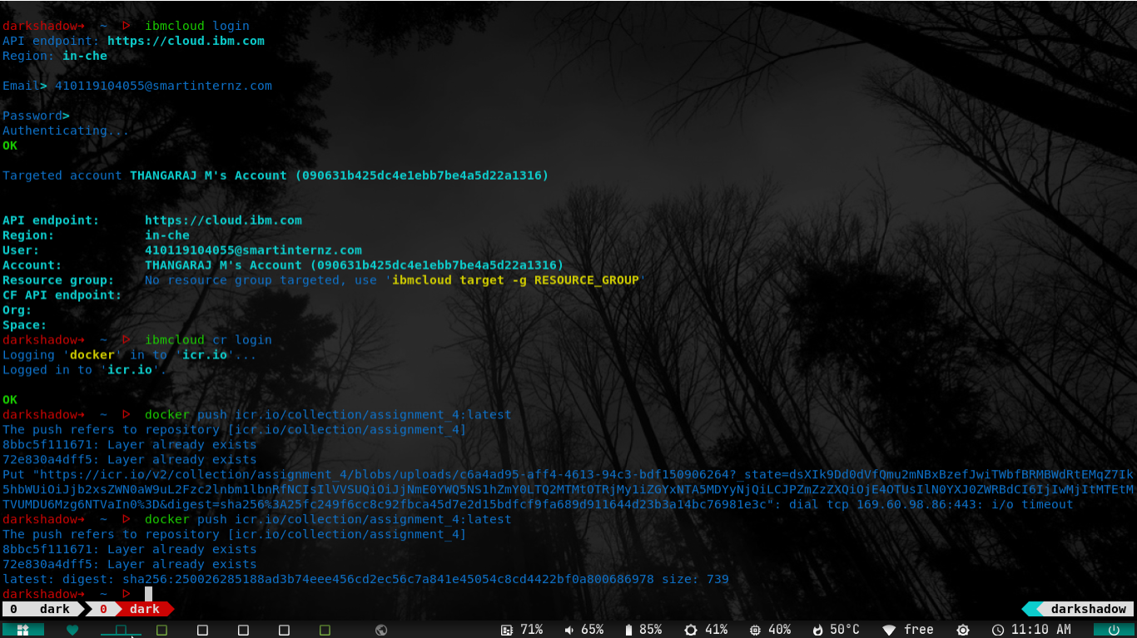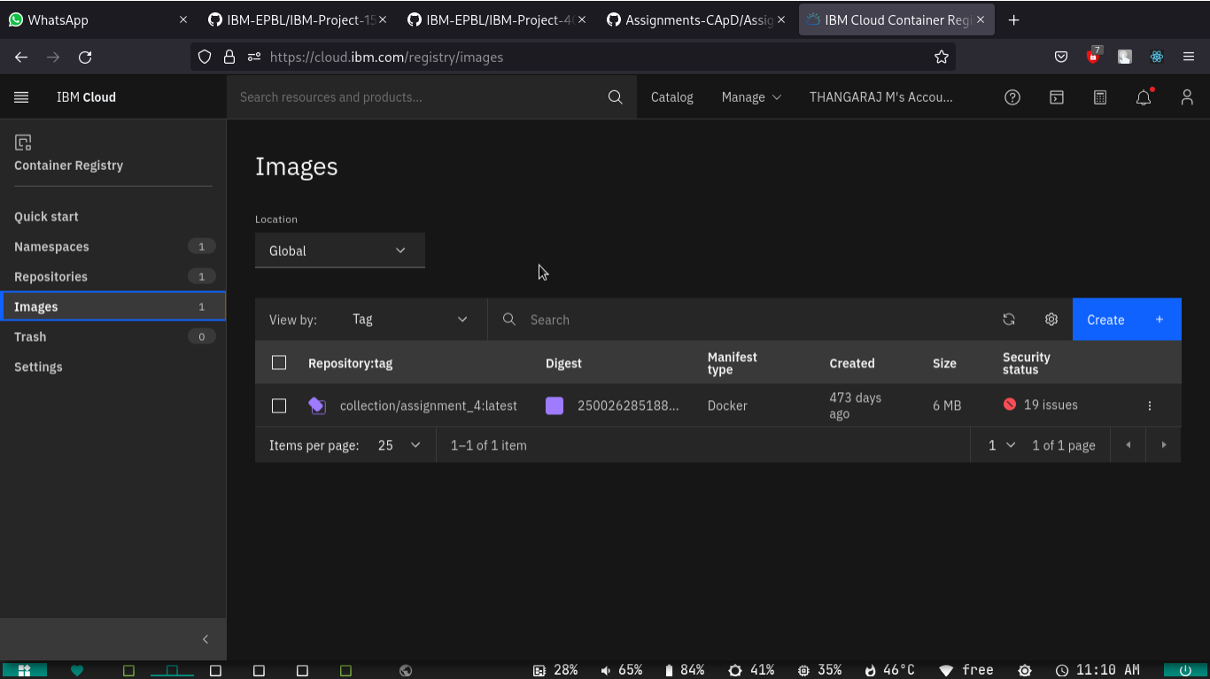3.Create a IBM container registry and deploy helloworld app or jobportalapp.

Question -4

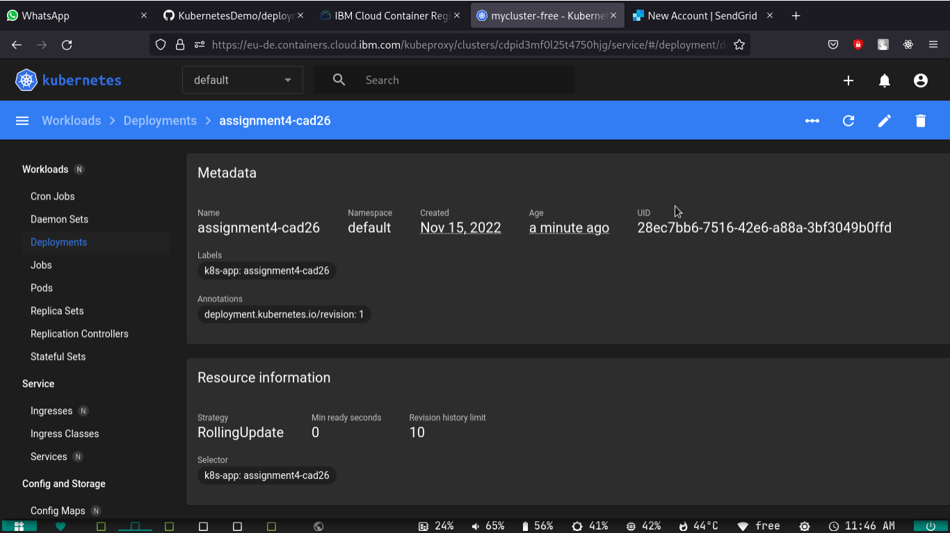4.Create a Kubernetes cluster in IBM cloud and deploy helloworld image or jobportal image and also expose the same app to run in nodeport.